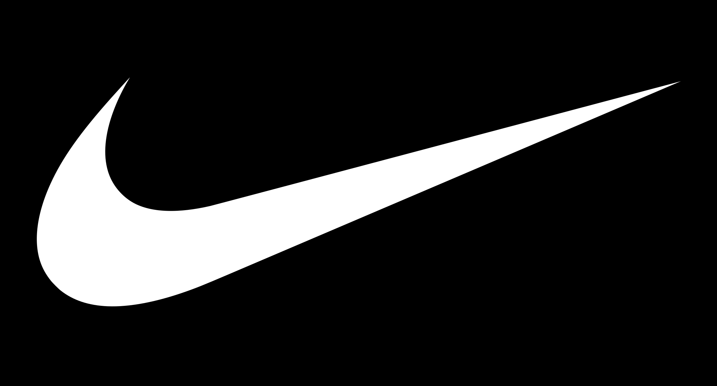

**JUST DO IT**

An investigation on Nike’s branding and its effect on the customer journey

Word Count: 1975

1. NAVIGATION
2. NAVIGATION

0.0 NAVIGATION

**TABLE OF CONTENTS**

0.0 NAVIGATION 2

1.0 SUMMARY 3

2.0 INTRODUCTION 4

3.0 MODELS 6

4.0 ANALYSIS 11

5.0 CONCLUSION 20

6.0 BIBLIOGRAPHY 21

**TABLE OF TABLES**

Table 1: SWOT analysis of the Nike brand 6

**TABLE OF FIGURES**

[Figure 1: Lebron James playing in the Nike Ambassador XIII 4](https://uniofnottm-my.sharepoint.com/personal/psyma18_nottingham_ac_uk/Documents/Nike%20E-Business%20V2.docx#_Toc133905214)

[Figure 2: Serena Williams and Michael Johnson competing in Nike-branded attire 5](https://uniofnottm-my.sharepoint.com/personal/psyma18_nottingham_ac_uk/Documents/Nike%20E-Business%20V2.docx#_Toc133905215)

[Figure 3: Aaker’s brand equity model (Source: Aaker, 1991) 7](https://uniofnottm-my.sharepoint.com/personal/psyma18_nottingham_ac_uk/Documents/Nike%20E-Business%20V2.docx#_Toc133905216)

[Figure 4: Brand Equity model – based on Keller’s definition (Source: Keller, 1993) 9](https://uniofnottm-my.sharepoint.com/personal/psyma18_nottingham_ac_uk/Documents/Nike%20E-Business%20V2.docx#_Toc133905217)

[Figure 5: The customer decision journey (Source: Elzinga et al., 2009) 10](https://uniofnottm-my.sharepoint.com/personal/psyma18_nottingham_ac_uk/Documents/Nike%20E-Business%20V2.docx#_Toc133905218)

[Figure 6: The customer decision process based on perceived brand equity 11](https://uniofnottm-my.sharepoint.com/personal/psyma18_nottingham_ac_uk/Documents/Nike%20E-Business%20V2.docx#_Toc133905219)

Figure 7: Financial information of the World’s largest sneaker brands (Source: statista, 2023) 12

[Figure 8: Colin Kapernick’s advertising campaign for Nike (Source: Abad-Santos, 2018) 13](https://uniofnottm-my.sharepoint.com/personal/psyma18_nottingham_ac_uk/Documents/Nike%20E-Business%20V2.docx#_Toc133905221)

[Figure 9: Custom Nike-Jordan brand ‘cleats’ worn by an NFL player (Source: Vinlove, 2022) 13](https://uniofnottm-my.sharepoint.com/personal/psyma18_nottingham_ac_uk/Documents/Nike%20E-Business%20V2.docx#_Toc133905222)

[Figure 10: Michael Jordan in his namesake Nike-craft shoe 14](https://uniofnottm-my.sharepoint.com/personal/psyma18_nottingham_ac_uk/Documents/Nike%20E-Business%20V2.docx#_Toc133905223)

[Figure 11: Josh Jacobs and Jimmy Butler; two examples of athletes that have faced resilience (i.e. homelessness) on their path to sporting achievement 16](https://uniofnottm-my.sharepoint.com/personal/psyma18_nottingham_ac_uk/Documents/Nike%20E-Business%20V2.docx#_Toc133905224)

[Figure 12: Nike’s logo changes throughout the years 16](https://uniofnottm-my.sharepoint.com/personal/psyma18_nottingham_ac_uk/Documents/Nike%20E-Business%20V2.docx#_Toc133905225)

[Figure 13: Nike’s revenue form the broad product range (Source: Statista, 2022) 17](https://uniofnottm-my.sharepoint.com/personal/psyma18_nottingham_ac_uk/Documents/Nike%20E-Business%20V2.docx#_Toc133905226)

[Figure 14: Nike’s e-commerce platform (Source: Nike.com, no date) 18](https://uniofnottm-my.sharepoint.com/personal/psyma18_nottingham_ac_uk/Documents/Nike%20E-Business%20V2.docx#_Toc133905227)

[Figure 15: StockX’s e-commerce platform (Source: StockX, no date) 19](https://uniofnottm-my.sharepoint.com/personal/psyma18_nottingham_ac_uk/Documents/Nike%20E-Business%20V2.docx#_Toc133905228)

[Figure 16: An assortment of Pharrell William’s Adidas collaboration: Supercolour Superstars 19](https://uniofnottm-my.sharepoint.com/personal/psyma18_nottingham_ac_uk/Documents/Nike%20E-Business%20V2.docx#_Toc133905229)

[Figure 17: Pharrell Williams (Source: thecut.com, 2023) 20](https://uniofnottm-my.sharepoint.com/personal/psyma18_nottingham_ac_uk/Documents/Nike%20E-Business%20V2.docx#_Toc133905230)

1. SUMMARY

1.0 SUMMARY

*What do Lebron James, a 14-year old Swanley resident and professional Cameroonian footballer have in common?*

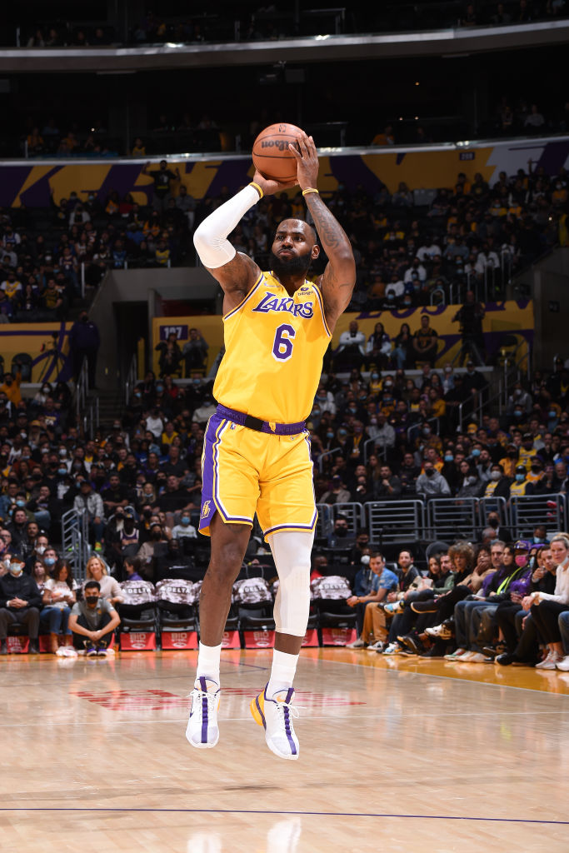

Figure 1: Lebron James playing in the Nike Ambassador XIII

This reports aims to dissect Nike Inc’s world-renown branding model, evaluating its successful e-business migration via two business lenses: the brand equity model and; the customer decision journey. After their definitions, their amalgamation will showcase their synergy – and Nike’s relationship with the wider world.

1. INTRODUCTION

2.0 INTRODUCTION

To contextualise this report: according to DataReportal’s global report, the internet is explored by 64.4% of the world’s population (Kemp, 2023). The current marketing environment has thus seen a paradigm-shift from one-way to two-way, customer-centric communication (Seamedu, 2023):

*in recent times, […] social media, and digital marketing have taken the forefront in marketing communication efforts*

The World Wide Web, Internet of Things and social networking have allowed unprecedented customer autonomy in the consumer industry – of which Nike capitalises upon (Huang, 2023b). Thence, Nike’s business strategy is thus: sports sponsorship and ambassadorship – to increase their reputability and image (Willigan, 2014).

Figure 2: Serena Williams and Michael Johnson competing in Nike-branded attire

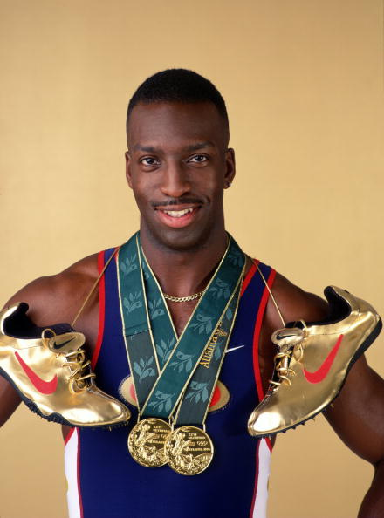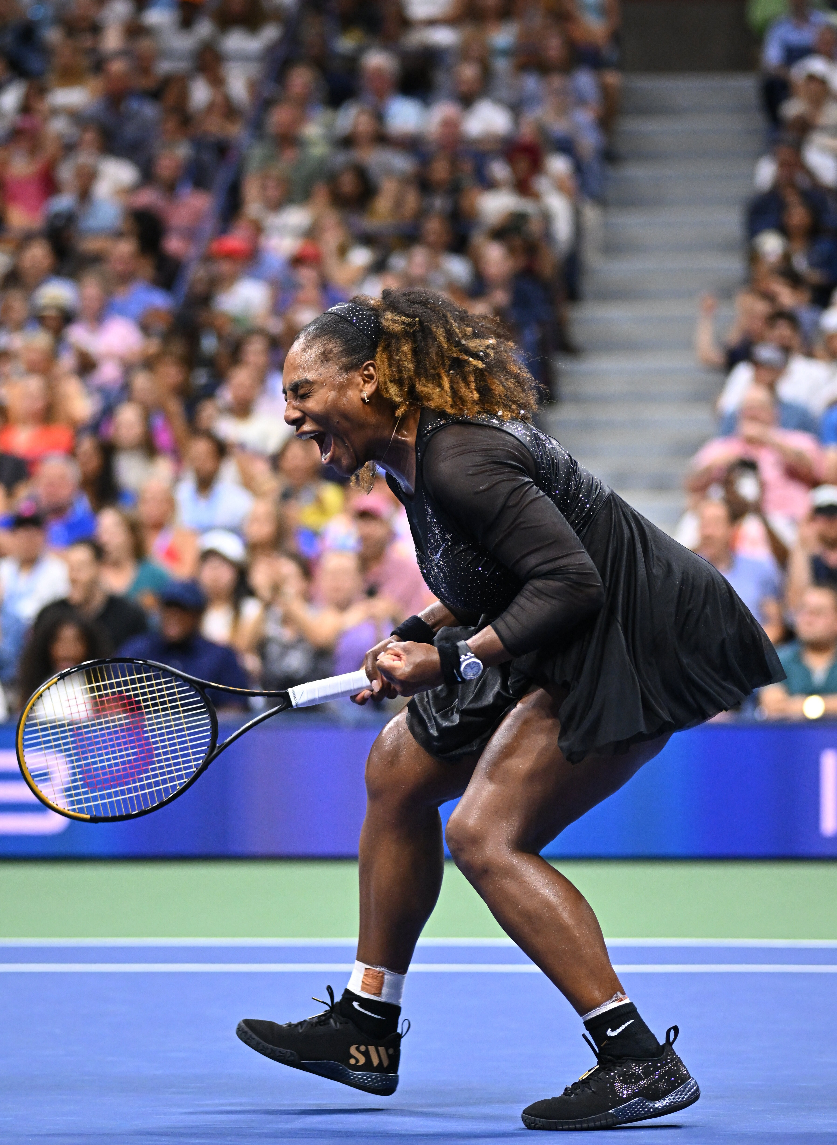

In addition to context, psychology-based definitions must be defined (Keller, 1993):

* Brand identities describe any *name, term, sign, symbol, or design, or combination of them which is intended to identify the goods and services of one seller*
* The brand is the amalgam of such recognisable identities
* Memory is simply the brain’s information storage
* Recognition is the mental exposure to a stimuli and ability to discern it
* Recall is the ability to utilise memory to retrieve stored information

Finally, Nike’s business model can be scrutinised based on its market position:

|  |  |
| --- | --- |
| **Strengths:** | **Weaknesses:** |
| * Brilliant brand building * Outsourced production * Global outreach * Unique in its approach | * Dependent on footwear market * Scandals around forced labour * Sells primarily through retailers * Recently seen as luxury-brand |
| **Opportunities:** | **Threats:** |
| * Emerging markets: China and India * Product diversification * Athleisure trend | * Dependent on global supply chain * Image damage due to exploitative pricing * Economic crisis * Over-diversification without strategy |

Table 1: SWOT analysis of the Nike brand

3.0 MODELS

1. Models

The employed models are the brand equity model and the customer decision journey.

The **brand equity model** evaluates the perceived value of a specific brand via collective memory (Huang, 2023b). Equity denotes its ability to be positive or negative, with the latter proving facilitating slow growth, loss of revenue and financial turmoil.

There are differing interpretations on brand equity, so this report will proceed with Keller’s interpretation (Keller, 1993). Aaker provides a comprehensive definition of brand equity with some concepts mirroring Keller’s. Aaker’s interpretation defines brand identities as (Aaker, 1991):

*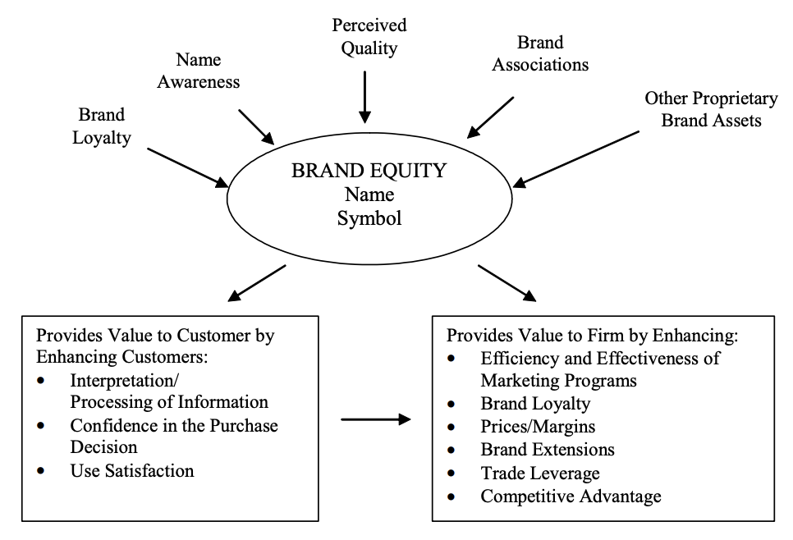A set of brand assets and liabilities linked to a brand, its name and symbol that add or subtract from the value provided to a firm and/or to that firm’s customer*

Figure 3: Aaker’s brand equity model (Source: Aaker, 1991)

Proceeding with Keller’s model: brand awareness comprises both brand recognition and recall. Alongside this, brand associations are powerful identifiers that can impact one’s opinion. They comprise:

* Benefits, which can be: experiential – “what its like to use”; functional – “how do they serve their purpose” or; symbolic – “what social gain is provided”
* Attitudes, which are salient beliefs about the brand in addition to critical evaluations of such

Brand association also includes attributes: physical features and uses of the product – split between: product attributes, the physical makeup of the brand’s items and; non-product attributes, such as packaging and pricing.

Finally, secondary associations can be crafted by knowledge of a brand’s ownership, or via one’s experience seeing brand ambassadors utilising product.

Majahan dictates numerous benefits of brand equity emphasis (Majahan et al., 1994):

* *Enhanced performance [and] market efficiency*
* *Longevity*
* *Extensibility*

While this is the case, critical thinking can elucidate the model’s pitfalls. Today’s age of information has created an abstraction between consumers and brands, increasing the difficulty in crafting customer connections (Garg, 2021; Llopis, 2014). In addition, brand equity is unsustainable without dedicated company teams, requiring resource allocation (i.e. Nike’s marketing department) (Willigan, 2014). Positive brand equity generation is an endeavour, especially due to the consumer attention-span shift (Llopis, 2014):

*Consumers are no longer brand loyal. They may be loyal to the engagement experience that a particular brand offers*

Thus, brand equity is costly, but beneficial. Its final critique is simply, its classification as a “model”: brand equity has numerous definitions and is not a unified marketing science; it is instead a methodology, employed to improve customer-relationship management (Feldwick, 1996).



Figure 4: Brand Equity model – based on Keller’s definition (Source: Keller, 1993)

The model can correctly identify weaknesses within a brand’s marketing strategy, but does not independently scrutinise the customer’s mental process during purchase (Huang, 2023b). Hence: McKinsey’s **customer decision journey**, introduced (Elzinga et al., 2009).

The customer decision journey updates and abstracts the “traditional” funnel model for decision-making; elucidating a cyclical customer process - by which customers re-engage with brands when deciding which to purchase from (Elzinga et al., 2009).



Figure 5: The customer decision journey (Source: Elzinga et al., 2009)

The benefits of this model are: its ability to map the factors that affect a customer’s brand decision and where companies can adjust for their own gain. It must be identified that this model is concerned with the **customer decision** – not with company-side moves, yet they are not mutually exclusive. The process seemingly begins once the customer desires a certain item – which, in modernity, could be spurred by necessity, or encouraged by media successfully instilling a perceived benefit of product ownership (Huang, 2023b; Llopis, 2014).

Henceforth – the brand equity model views features that alter public perception of brand value; whilst the customer decision journey focuses on consumer’s buying habits, and how such aforementioned perceptions can inform their purchasing decisions.

Note:the 7 Cs – Context, Content, Community, Customisation, Communication, Connection and Commerce (Oliver, no date): can be directly connected to success within the customer’s active evaluation stage.

Consequently, a full marketing evaluation model is discerned:

Of note is the marketing team’s responsibility for message encoding, via media, for public consumption, in case message misinterpretation harms the brand.

Figure 6: The customer decision process based on perceived brand equity

4.0 ANALYSIS

1. ANALYSIS

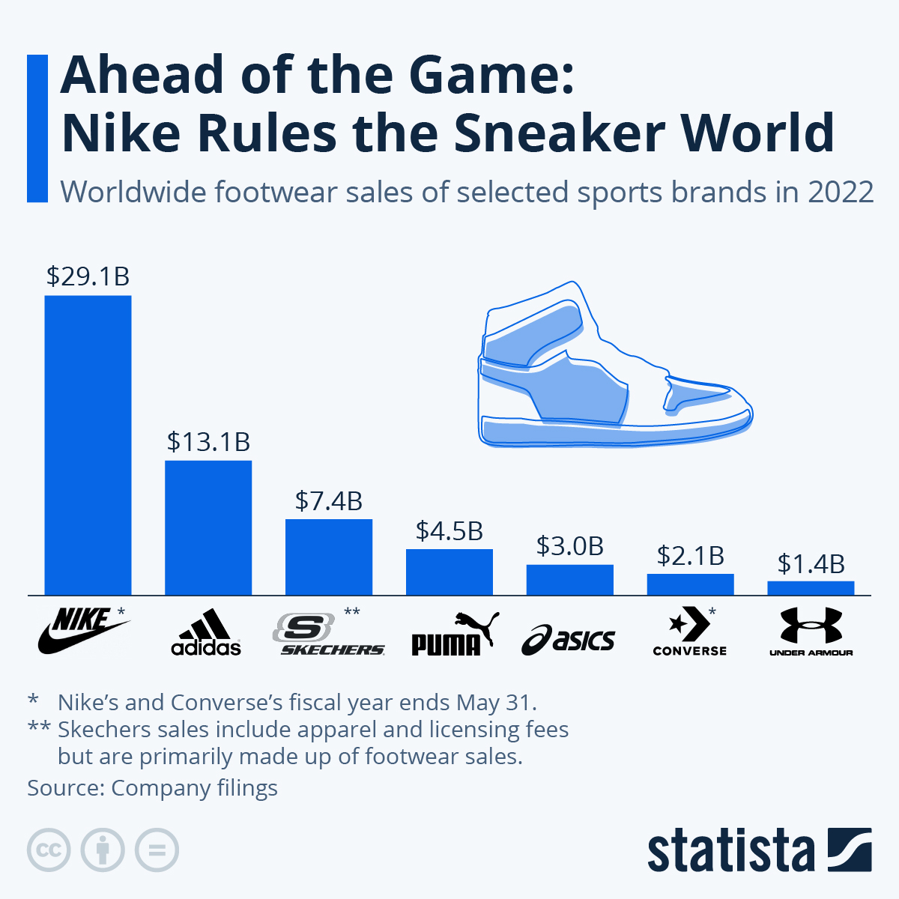Nike currently holds a 38% market share in the athletic clothing industry (Investing.com, 2023).

Figure 7: Financial information of the World’s largest sneaker brands (Source: statista, 2023)

As mentioned before, Nike’s strategy consists of excellent sports ambassadorship alongside well-planned sub-branding to accelerate brand recognition. For instance: the NFL’s super bowl, boasted 113m viewers in 2023 (Johnson, 2023). Nike endorses (and designs) the NFL’s kits, increasing recognition (Liberto, 2020). Nike’s market message encoding is known for its simplicity and directness: Nike aims to relate every viewer to a world-renown athlete, through emotional advertising (Wu, 2022). Within the brand equity model and during the initial decision stage: Nike has already outclassed its competition, placing identifiable figures at the forefront of their marketing campaigns, and allowing passive advertisement through viewers watching 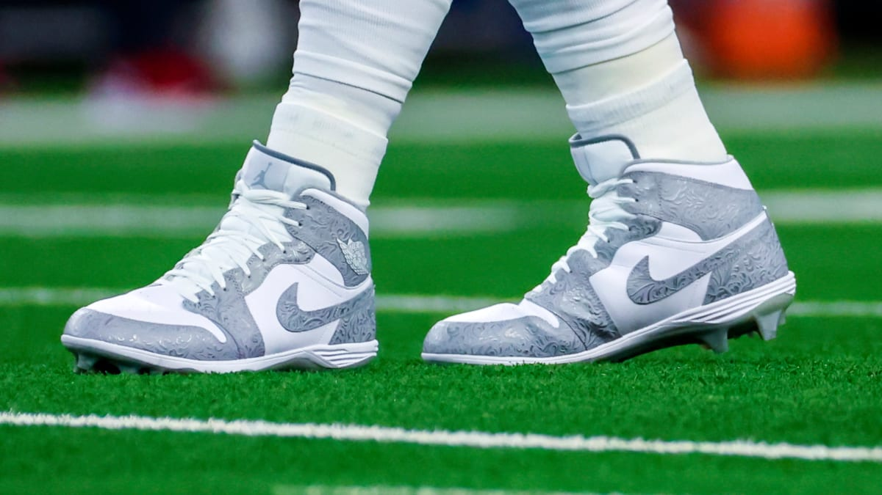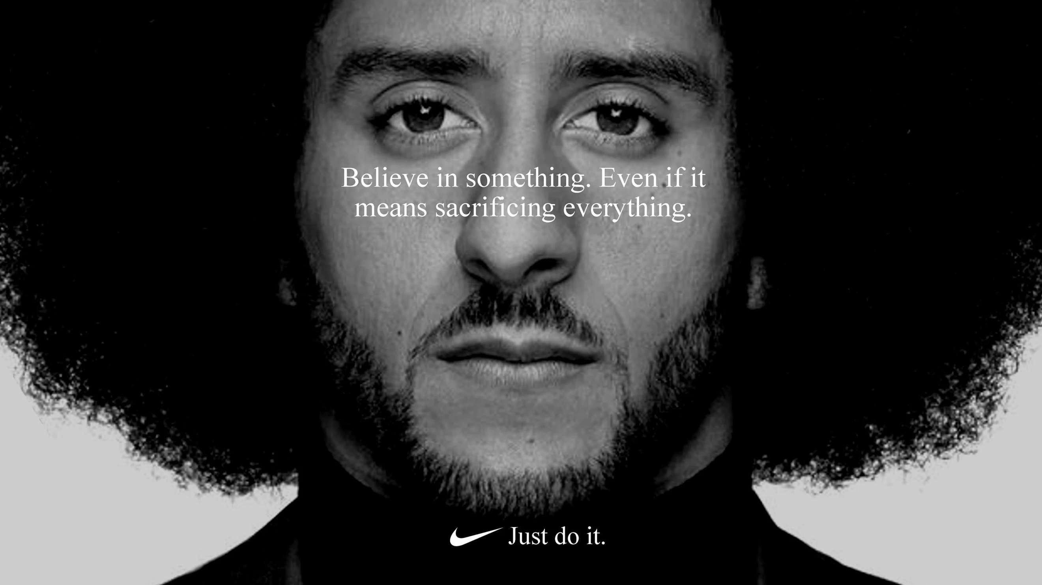athletes perform (Abad-Santos, 2018; Vinlove, 2022).

Figure 8: Colin Kapernick’s advertising campaign for Nike (Source: Abad-Santos, 2018)

Figure 9: Custom Nike-Jordan brand ‘cleats’ worn by an NFL player (Source: Vinlove, 2022)

These methods mirror automotive product-placement within cinema, and is seemingly as effective (Lewin, 2022). In-accordance with the consumer-led revolution: viewing athletes perform in Nike gear strengthens one’s brand recall, while building trustworthiness that translates into both functional and symbolic benefit (Keller, 1993). A thought can illustrate this:

“If Michael Jordan won Defensive Player of the Year and an NBA Championship in Nike-crafted footwear: I can win my college basketball game in Nike too.”

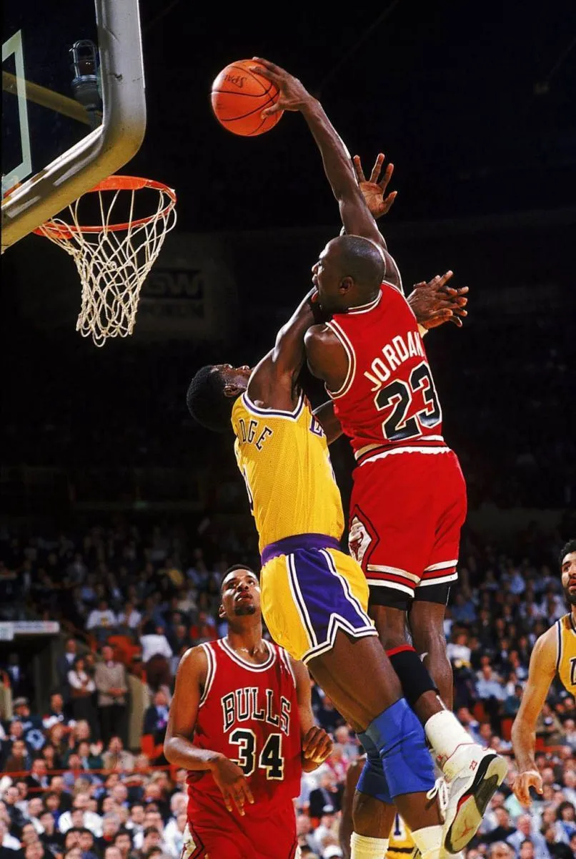Whilst a fictitious statement, it elucidates the perceived gain that a Nike product purchase could make. While these athlete stories attract an audience to Nike’s brand, they can also deter leisure consumers (Willigan, 2014). It is evident, that athleisure clothing holds its fair share of issues (TechnoGym, no date). Nike is not excluded from this: their pursuit of a reasonable balance of athletic and apparel footwear warrants scepticism from extreme fashion consumers and elite-echelon athletes (TICMall, 2022). Nike does mitigate this through specification within sub-branding; however, Nike’s own popularity creates issues: evidenced by the Jordan sub-brand.

Figure 10: Michael Jordan in his namesake Nike-craft shoe

Jordan’s, designed for Jordan’s on-court performance, were marketed as the ultimate basketball footwear, yet, their popularity has since mythologised them in fashion (Wilbekin, 2023). This creates difficulty designing future products, which must balance comfort with performance (Levine, 2022).

To exemplify this: a consumer – fictitiously named Rose – wishes to purchase basketball shoes for an upcoming game. While she has recalled and considered Jordan’s in her initial exploration, she has read reviews on an external brand’s in-game effectiveness and, coupled with her pre-conceived attitude of Jordan’s being an aesthetic line: she removed Nike from her active evaluation (Wilbekin, 2023; Levine, 2022, TICMall, 2022).

Nike’s brand equity is extremely dependent on secondary association. The adoption of ambassadors and sponsorship could be deemed risk-seeking: generating high profits from athletic performance yet allowing huge cash-loss amidst scandal. Evidencing this: the Fifa scandal of 2015 lead to a noticeable revenue decrease, due to Nike’s ill-placed decision to “seemingly” endorse corruption (Sports Business Journal, 2015; McGreal, 2015). Furthermore, disgraced athletes can damage Nike’s image of perseverance and athletic success through hard-work, such as with Lance Armstrong’s doping scandal (Williams, 2012). The largest threat, however, is undoubtedly the loss of loyal customers – who usually bypass external exploration due to their familiarity with the Nike product (Elzinga et al., 2009).

Acknowledging Nike’s brand strategy’s pitfalls, numerous solutions exist. For the initial decision process, it is recommended that Nike refrains from sponsorship of entire sporting events. There are too many unknown factors (from Nike’s intelligence’s viewpoint) that could lead to reputational disaster (Sports Business Journal, 2015). Additionally, Nike should aim to further promote **proven**, **trustworthy**, **dependable** athletes that have displayed engaging stories and excellent resilience in their careers.

In coherence, Nike should either separate their product lines further, **or** provide analysis on product performance for athletic events.

Figure 11: Josh Jacobs and Jimmy Butler; two examples of athletes that have faced resilience (i.e. homelessness) on their path to sporting achievement

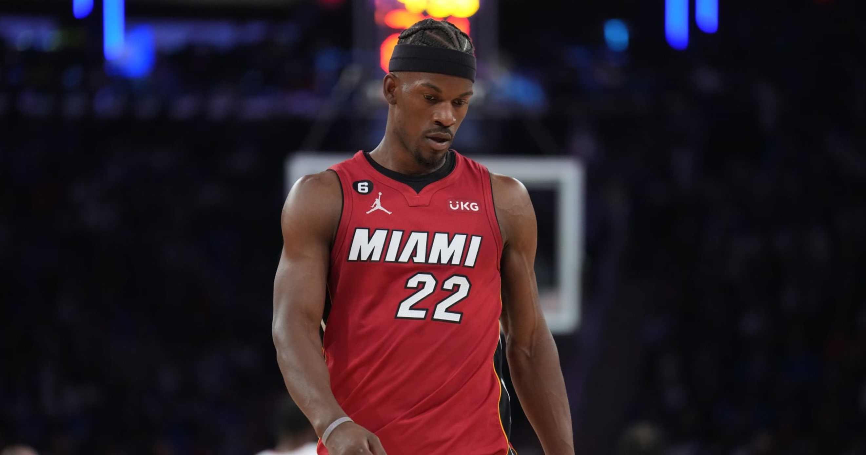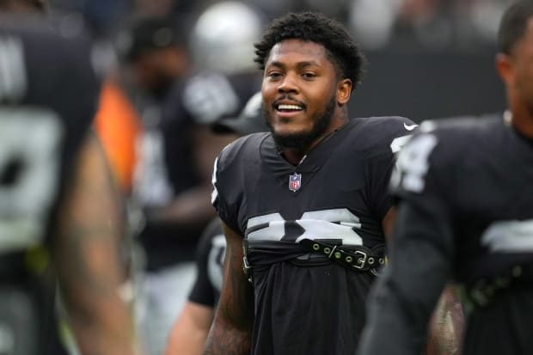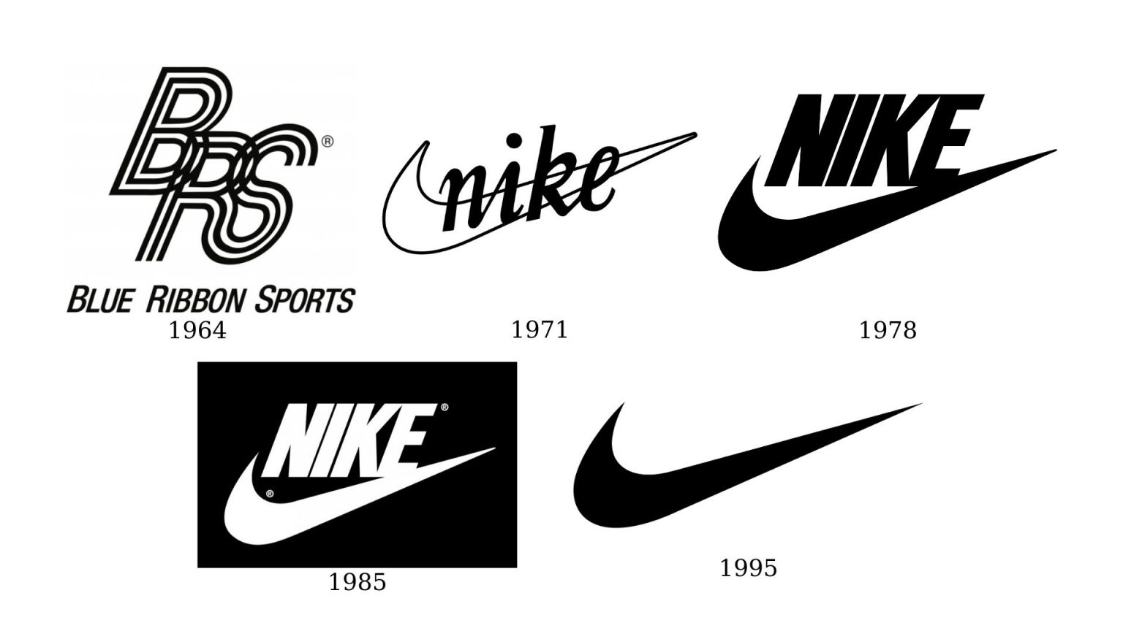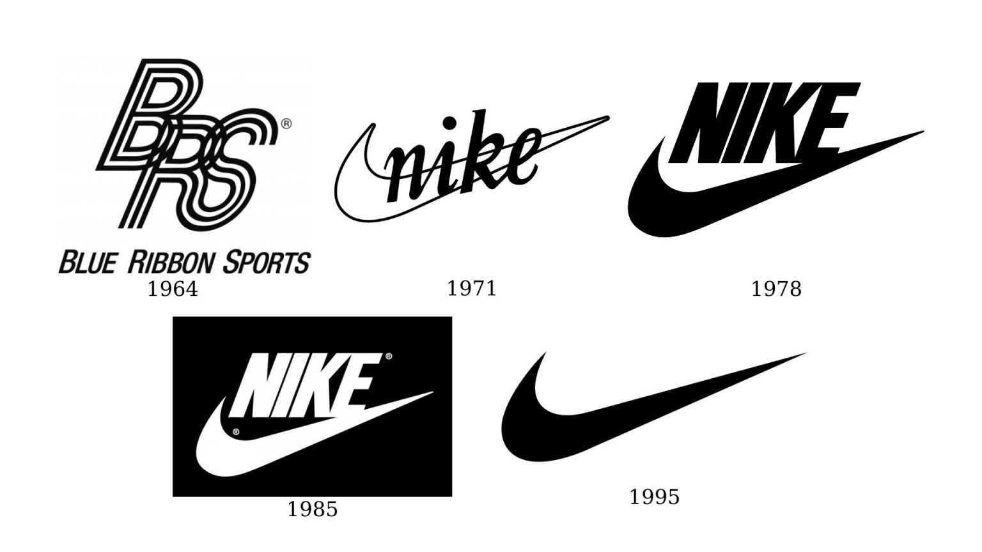

An aside: Nike’s choice of name and logo are deliberately manipulate brand awareness (Keller, 1993). *Nike*, named for the Greek goddess of victory, is both unique and semantically symbolic of their mission (Nike.com, no date). The name’s uniqueness makes it recognisable amongst product assortments, whilst the swoosh logo is iconic and easy to instantly recall. This swoosh deliberately adorns Nike’s product packaging, a brand attribute that is expertly leveraged for benefit (Keller, 1993). Both contribute to an exceptional global brand awareness.

Figure 12: Nike’s logo changes throughout the years

Assuming positive brand equity, during the active evaluation phase, Nike’s e-commerce platform applies the 7-Cs effectively to gain a competitive edge (Huang, 2023a; Oliver, no date).

Nike’s website eloquently integrates both aesthetic design and ergonomics (Nielsen, 1994). The search and purchase processes are simplistic and accessible; the site avoids latency and; the structure is well-distributed with its emphasis on products (Nike.com, no date). Additionally, Nike’s content holds both breadth and depth, boasting a wide product range with many personalisation options. (Tighe, 2022).

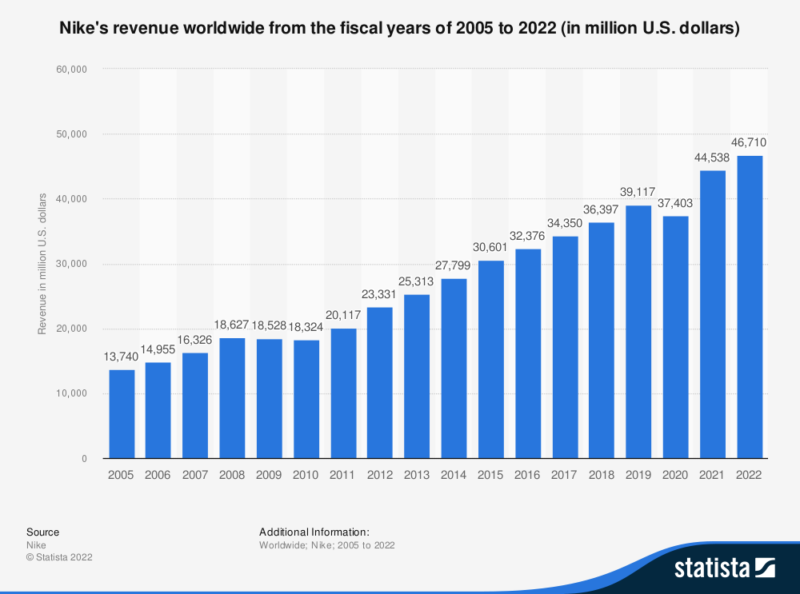

Figure 13: Nike’s revenue form the broad product range (Source: Statista, 2022)

Figure 14: Nike’s e-commerce platform (Source: Nike.com, no date)

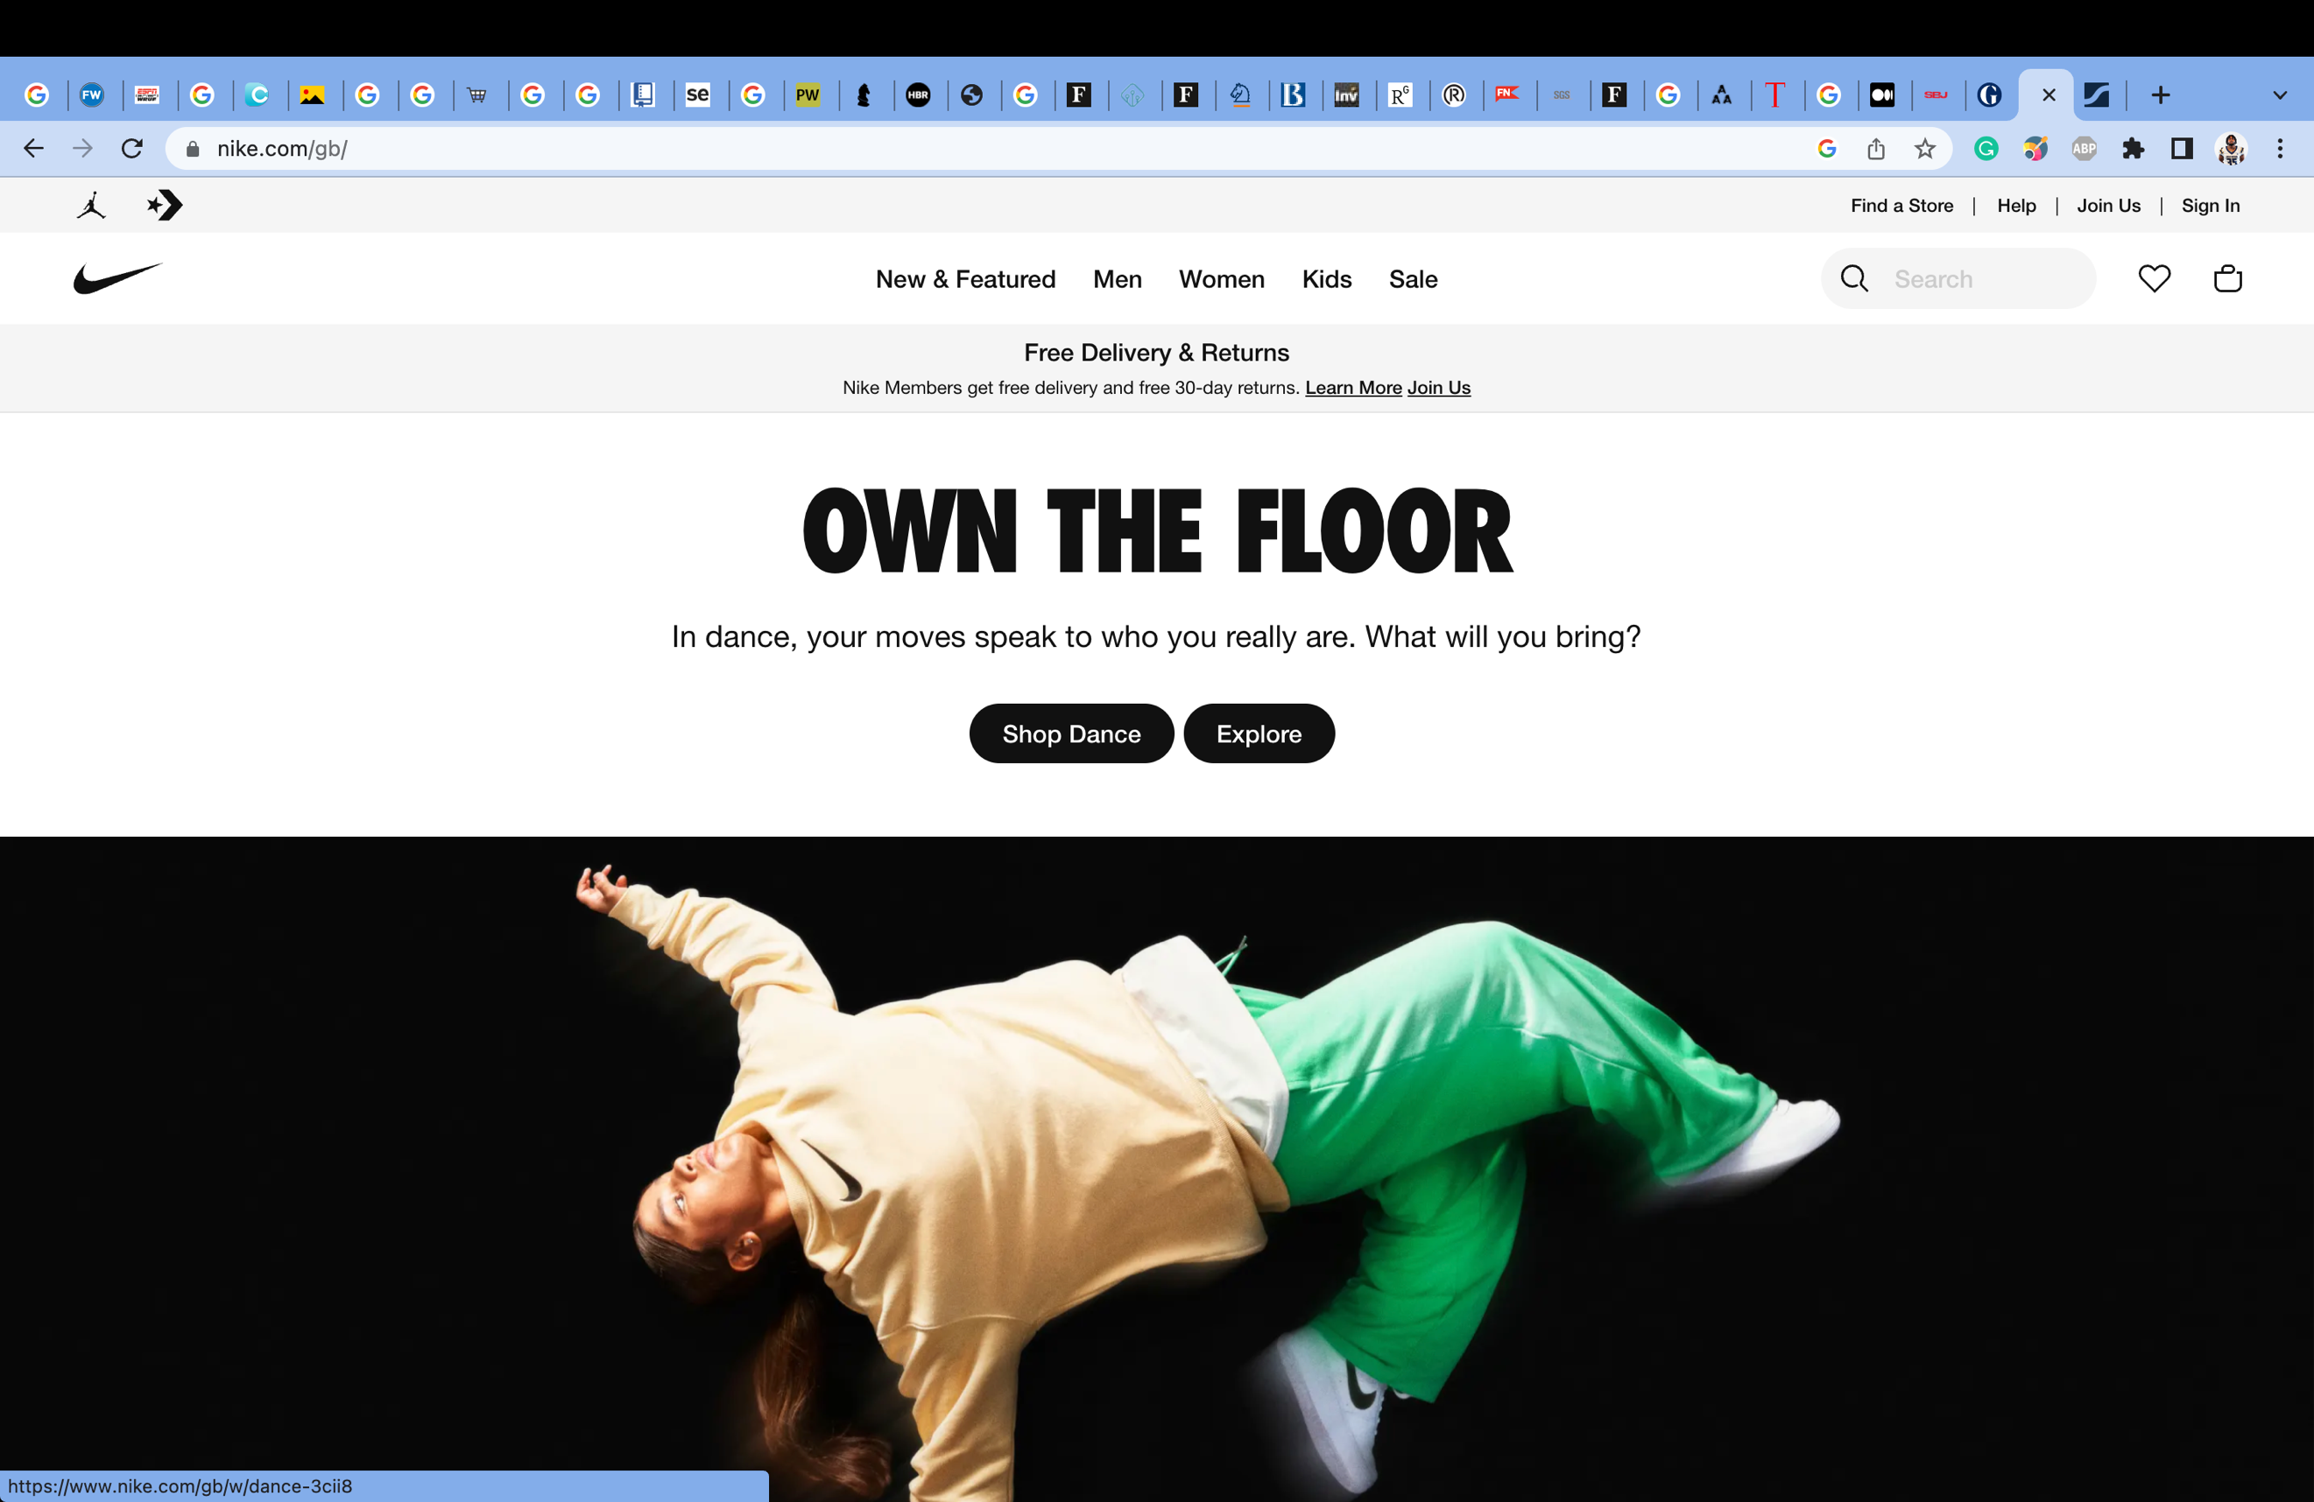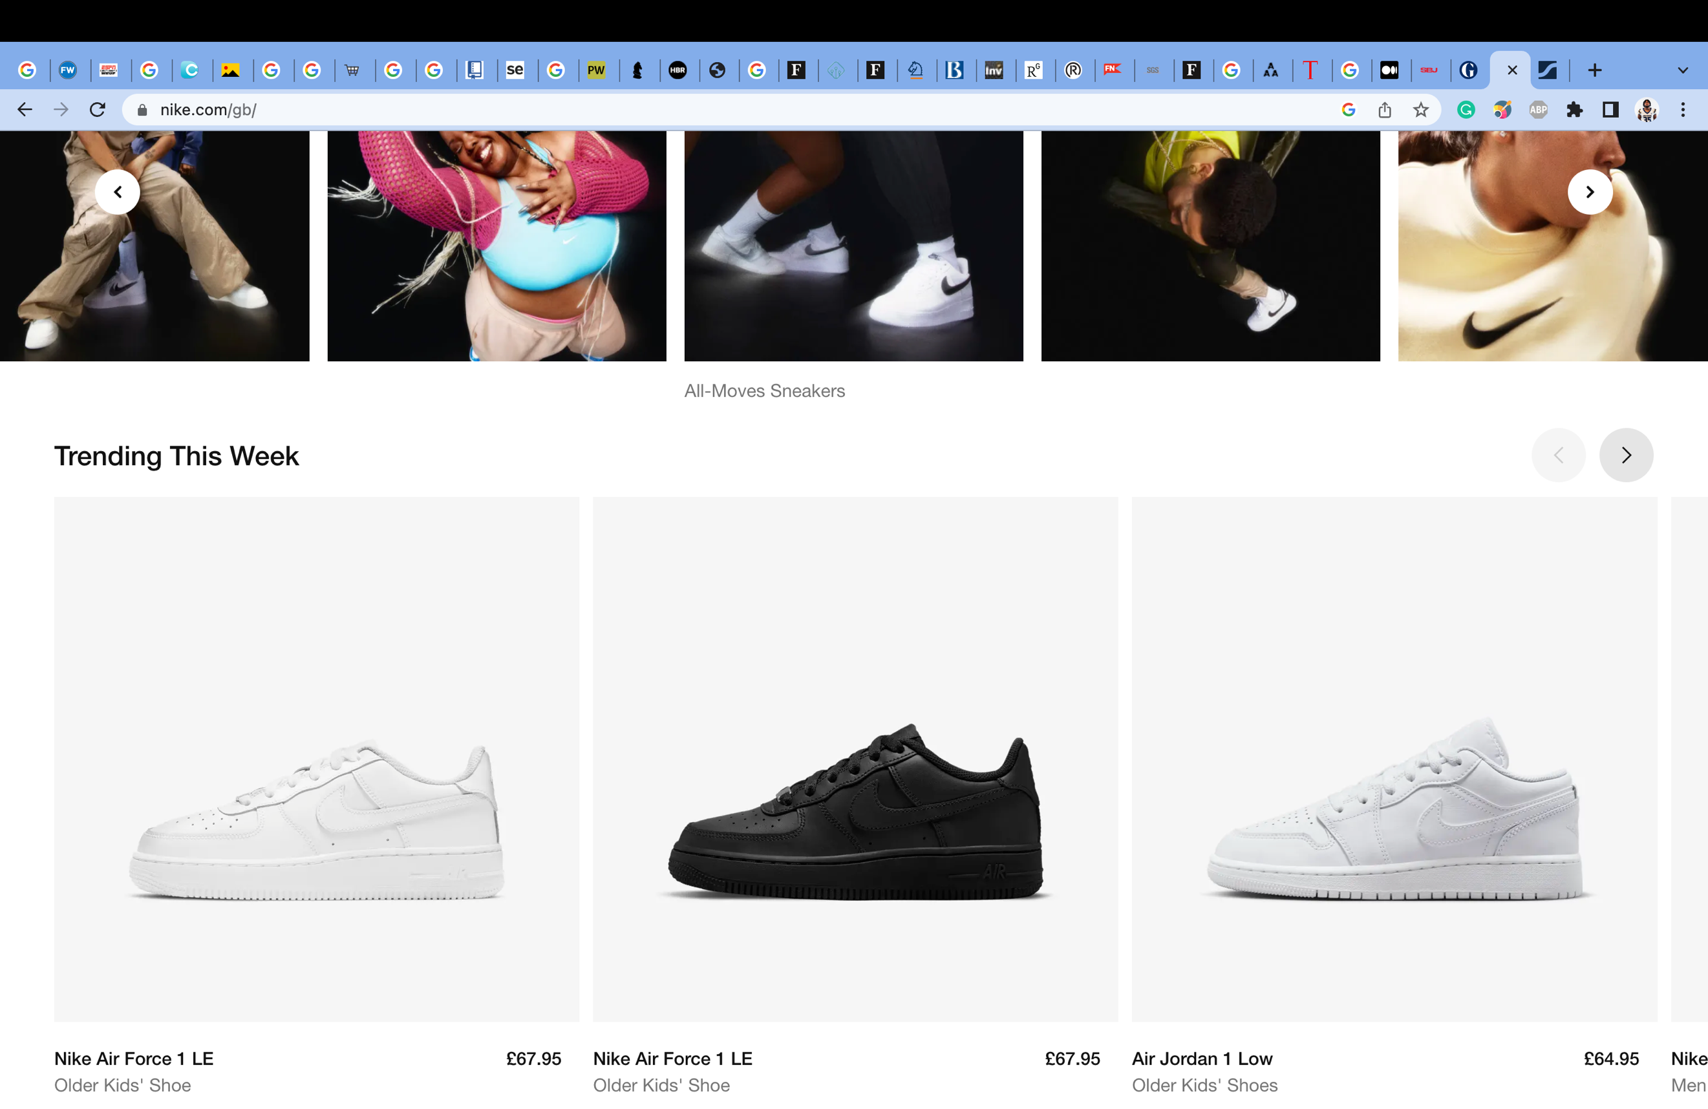

Nike ensures accessible customer communication, yet their customer decision journey is afflicted by a lack of social network for Nike products. It is notoriously known that most sale of premium Nike products occurs outside of Nike’s jurisdiction, highlighting an area of opportunity by to allowing auctioning and direct peer-to-peer sale of 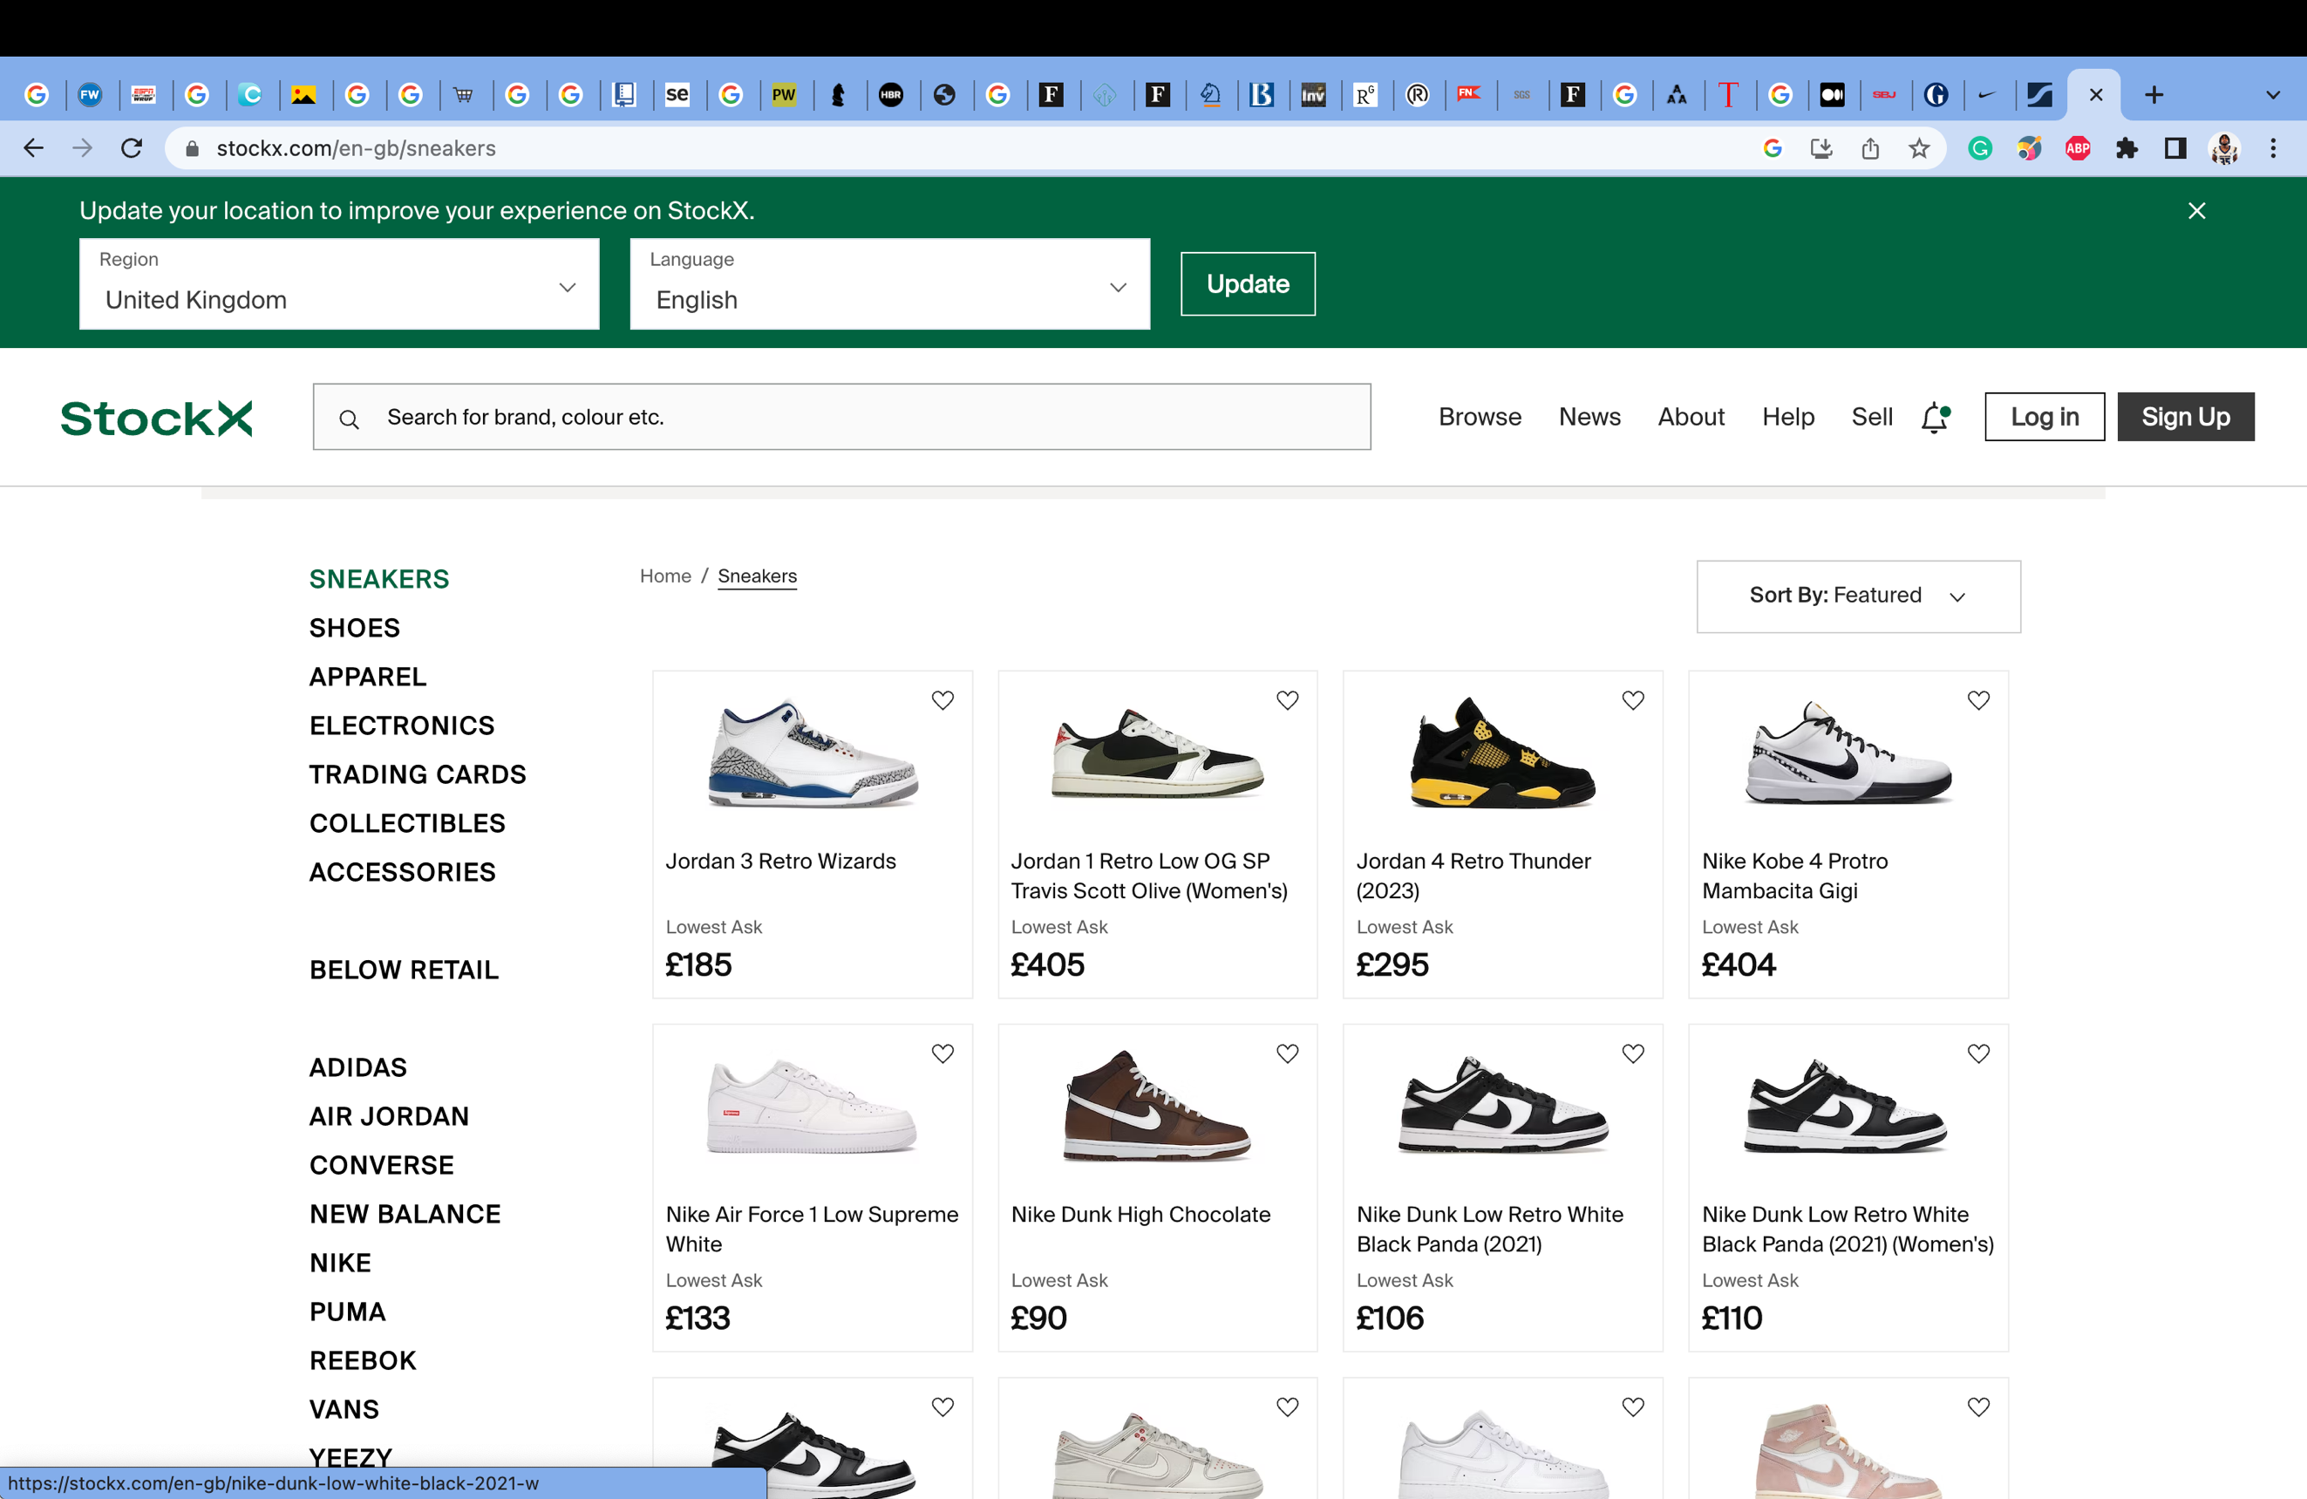product (StockX, no date).

Figure 15: StockX’s e-commerce platform (Source: StockX, no date)

Despite this, Nike’s e-commerce platform aids in the facilitation of progression towards customer purchase.

While allowing for positive consumer experience and an increased likelihood of purchase, Nike’s leisure options seem less adequate than other brands. Adidas exemplifies a differing secondary association than Nike’s; utilising artists and musicians to produce distinct shoe-lines, as opposed to athletes. A recommendation is thus to recruit those within the entertainment sector, to produce new Nike lines, in addition to the already established athlete-base.

Figure 16: An assortment of Pharrell William’s Adidas collaboration: Supercolour Superstars

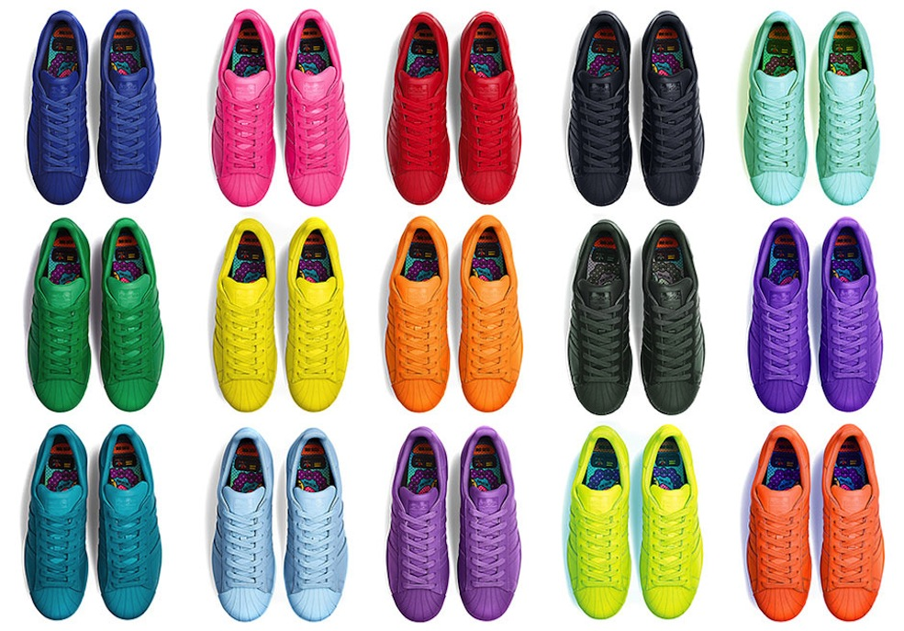

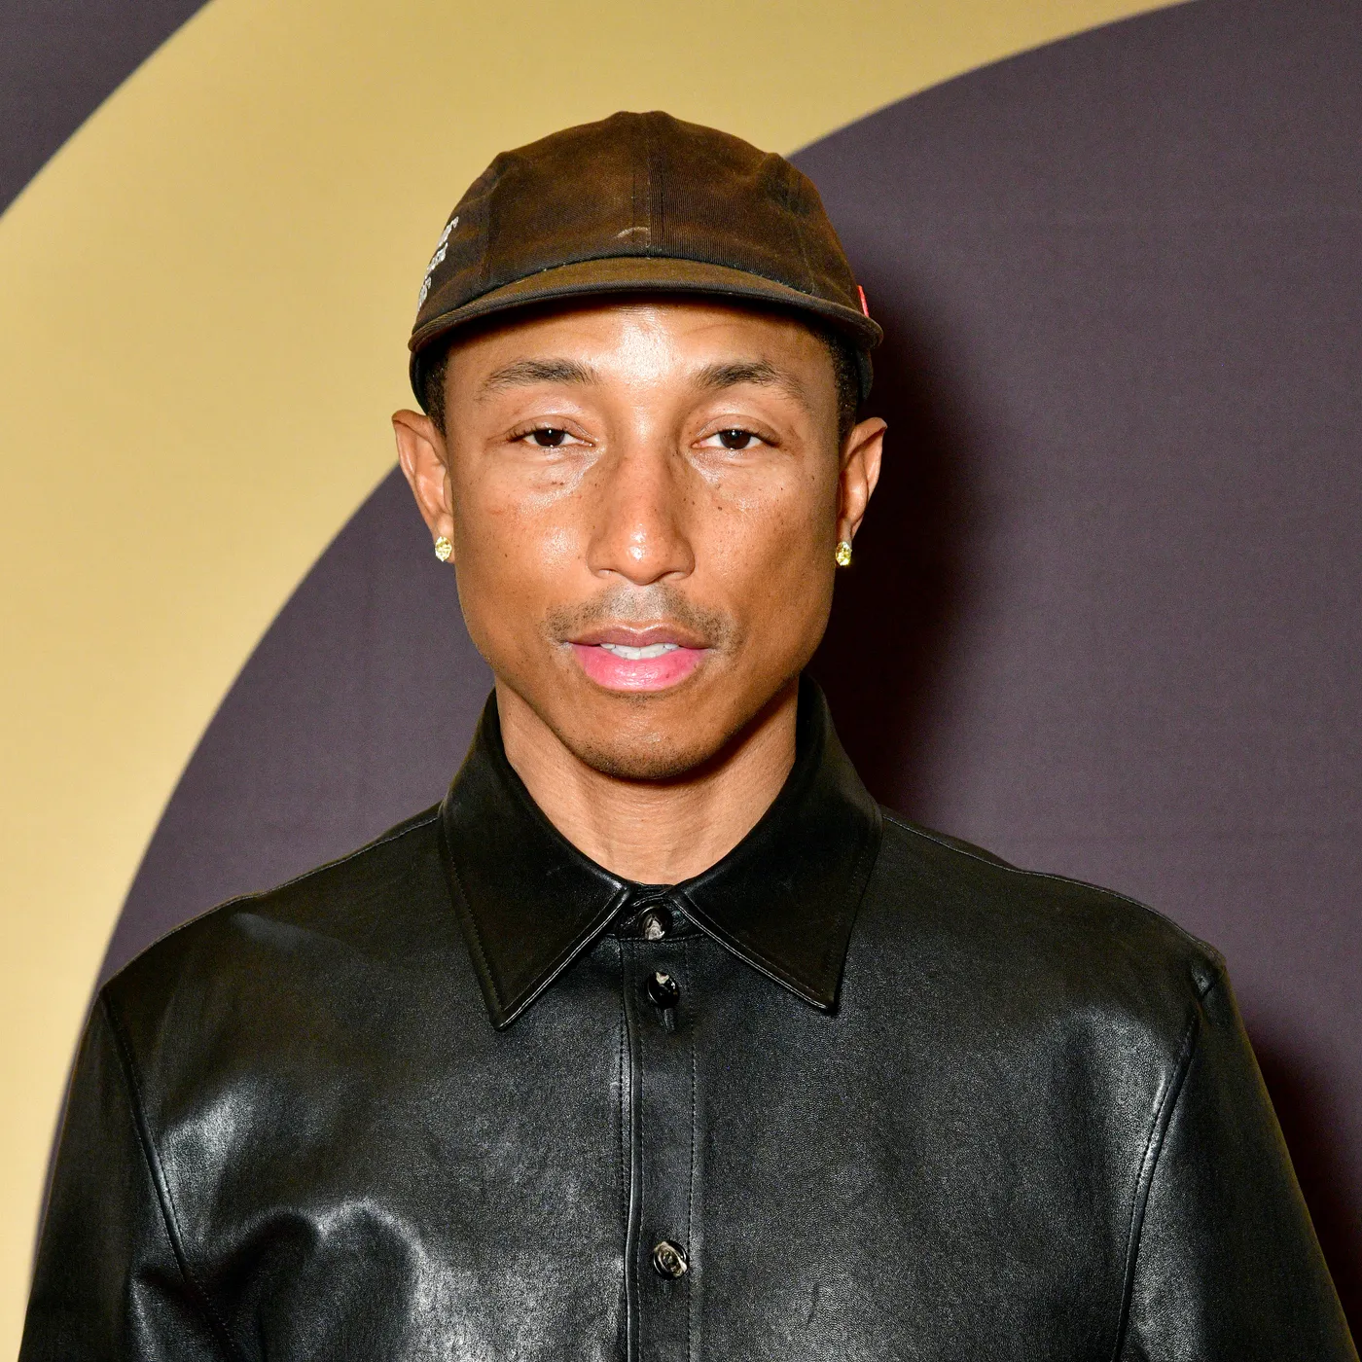

Figure 17: Pharrell Williams (Source: thecut.com, 2023)

To improve across both the customer decision journey and Nike’s brand model, emphasis must be placed on new, neglected user journeys. Nike could invest in those far removed from sport: providing purely leisure footwear

or, dedicate themselves entirely to athletic-wear (Willigan, 2014). In conjunction, Nike should aim to increase ambassadorship outside of the “western world”: a number of unique sports are played on the Indian sub-continent, for instance, which offers a large enough population to impact revenue (Farooqui, 2022). To illustrate this, an advertisement campaign within the sport of Kabaddi could hold huge benefit for Nike and their brand (Farooqui, 2022). Similarly, Nike, understandably, currently holds no presence in the corporate-world; an area for expansion if marketed correctly (Sidhu, 2014).

5.0 CONCLUSION

1. CONCLUSION

Nike’s brand is instantaneously recognisable. This is through the strategic leveraging of athletes to enforce brand exposure. While this is highly effective within Nike’s sphere of influence; there are numerous avenues to better brand development, even in lieu of their global dominance. Nike’s largest issue is a semantic one: the encoding of Nike’s media has diffused a clear interpretation of the Nike shoe: is it solely for leisure or solely for competition?

6.0 BIBLIOGRAPHY

1. BIBLIOGRAPHY

* Aaker, David A. (1991). Managing Brand Equity, New York: The Free Press
* Abad-Santos, A. (2018) *Nike's Colin Kaepernick ad sparked a boycott - and earned $6 billion for Nike*, *Vox*. Vox. Available at: https://www.vox.com/2018/9/24/17895704/nike-colin-kaepernick-boycott-6-billion (Accessed: April 25, 2023).
* *Buy and Sell Sneakers* (no date) *StockX*. Available at: https://stockx.com/en-gb/sneakers (Accessed: April 26, 2023).
* Elzinga, D. *et al.* (2009) *The consumer decision journey*, *McKinsey & Company*. McKinsey & Company. Available at: https://www.mckinsey.com/capabilities/growth-marketing-and-sales/our-insights/the-consumer-decision-journey (Accessed: April 25, 2023).
* Farooqui, J. (2022) *Season 9: Kabaddi League viewership crosses 200-million mark*, *The Economic Times*. Available at: https://economictimes.indiatimes.com/news/sports/season-9-kabaddi-league-viewership-crosses-200-million-mark/articleshow/96207385.cms?from=mdr (Accessed: April 26, 2023).
* Feldwick, P. (1996) “Do we really need ‘brand equity’?,” *Journal of Brand Management*, 4(1), pp. 9–28. Available at: https://doi.org/10.1057/bm.1996.23.
* *From Athleisure to wellness: How movement and well-being ... - technogym* (no date) *TechnoGym*. Available at: https://www.technogym.com/gb/newsroom/athleisure-to-wellness-trendy-movement/ (Accessed: April 25, 2023).
* Garg, N. (2021) *Advantages and disadvantages of brand equity*, *TheSERPwire*. Available at: https://theserpwire.com/advantages-and-disadvantages-of-brand-equity/#b_disadvantages_of_brand_equity (Accessed: April 25, 2023).
* *How does athleisure wear affect your workout performance* (2022) *SGS TIC Mall*. Available at: https://ticmall.sgs.com/blogs-is-how-does-athleisure-wear-affect-your-workout-performance/ (Accessed: April 25, 2023).
* Huang, J. (2023a) “Customer Interface,” *E-Business (BUSI4458 UNUK) (SPR1 22-23)*. Nottingham: United Kingdom, 20 February.
* Huang, J. (2023b) “Market Communications, Branding & CRM ,” *E-Business (BUSI4458 UNUK) (SPR1 22-23)*. Nottingham: United Kingdom, 27 February.
* Johnson, M. (2023) *NFL TV Ratings*, *Sportsnaut*. Available at: https://sportsnaut.com/nfl-tv-ratings-viewership-numbers/ (Accessed: April 25, 2023).
* Keller, K.L. (1993) “Conceptualizing, measuring, and managing customer-based Brand Equity,” *Journal of Marketing*, 57(1), p. 1. Available at: https://doi.org/10.2307/1252054.
* Kemp, S. (2023) *Digital 2023: Global Overview Report - DataReportal – Global Digital Insights*, *DataReportal*. DataReportal – Global Digital Insights. Available at: https://datareportal.com/reports/digital-2023-global-overview-report (Accessed: April 25, 2023).
* Levine, A. (2022) *Are Air Jordan 1s good for basketball?*, *All About Anthony*. Available at: https://www.allaboutanthony.com/air-jordan-1-good-for-basketball/ (Accessed: April 26, 2023).
* Lewin, A. (2023) *"deep product placement": The implications of the Nike-netflix partnership*, *Inside Retail*. Available at: https://insideretail.com.au/business/deep-product-placement-the-implications-of-the-nike-netflix-partnership-202301 (Accessed: April 25, 2023).
* Liberto, D. (2020) *Nike, NFL extend partnership through 2028*, *Investopedia*. Investopedia. Available at: https://www.investopedia.com/news/nike-nfl-extend-partnership-through-2028/ (Accessed: April 25, 2023).
* Llopis, G. (2016) *Consumers are no longer brand loyal*, *Forbes*. Forbes Magazine. Available at: https://www.forbes.com/sites/glennllopis/2014/12/10/consumers-are-no-longer-brand-loyal/?sh=469b10d72ae0 (Accessed: April 25, 2023).
* Mahajan, Vijay, Vithala, R. Rao, and Srivastava, Rajendra K. (1994). An Approach to Assess the Importance of Brand Equity in Acquisition Decisions, Journal of Product Innovation Management, 11, 221-235
* McGreal, C. (2015) *Nike dragged into FIFA crisis – but will its brand be damaged?*, *The Guardian*. Guardian News and Media. Available at: https://www.theguardian.com/football/2015/may/29/nike-fifa-crisis-brand (Accessed: April 25, 2023).
* Nielsen, J. (1994). Enhancing the explanatory power of usability heuristics. Proc. ACM CHI'94 Conf. (Boston, MA, April 24-28), 152-158.
* *Nike* (no date) *nike.com*. Available at: https://nike.com/gb (Accessed: April 26, 2023).
* *Nike dragged into FIFA corruption crisis over deal with Brazilian National Team* (2015) *Sports Business Journal*. Sports Business Journal. Available at: https://www.sportsbusinessjournal.com/Global/Issues/2015/06/01/Marketing-and-Sponsorship/Nike-FIFA-crisis (Accessed: April 25, 2023).
* *Nike's Mission* (no date) *About.nike.com*. Available at: https://about.nike.com/en (Accessed: April 26, 2023).
* Oliver, D. (no date) *7c’s of Website Design*, *Internet marketing reference*. Available at: https://blogs.baruch.cuny.edu/cwdoliver/7cs-of-website-design/ (Accessed: April 25, 2023).
* Richter, F. (2023) *Infographic: Ahead of the game: Nike Rules the sneaker world*, *Statista Infographics*. Available at: https://www.statista.com/chart/13470/athletic-footwear-sales/#:~:text=Athletic%20Footwear&text=With%20footwear%20sales%20of%20%2429,in%20the%20global%20sneakers%20market. (Accessed: April 25, 2023).
* Sidhu, R. (2014) *Clothsurgeon reconstructs Nike Fleece into a customized "sweatsuit"*, *Hypebeast*. Hypebeast. Available at: https://hypebeast.com/2014/10/clothsurgeon-customizes-sweatsuit-with-nike-tech-pack (Accessed: April 26, 2023).
* *The Evolution of Marketing Communications Management* (2023) *Seamedu*. Available at: https://www.seamedu.com/blog/the-evolution-of-marketing-communications-management#:~:text=The%20evolution%20of%20the%20concept,forefront%20in%20marketing%20communication%20efforts. (Accessed: April 25, 2023).
* Tighe, D. (2022) *Nike Annual Revenue Worldwide 2022*, *Statista*. Available at: https://www.statista.com/statistics/241683/nikes-sales-worldwide-since-2004/ (Accessed: April 26, 2023).
* *Unleashing the POWER OF DATA: A statistical analysis of Nike's rise to the top of the sporting industry* (2023) *Investing.com*. Available at: https://www.investing.com/academy/statistics/nike-facts/ (Accessed: April 25, 2023).
* Vinlove, J. (2022) *Jordan brand supplies NFL players with rare cleats*, *Sports Illustrated*. Available at: https://www.si.com/fannation/sneakers/news/jordan-brand-supplies-nfl-players-with-rare-cleats (Accessed: April 26, 2023).
* Wilbekin, E. (2023) *How the jordan 1 became the sneaker of a generation*, *Time*. Time. Available at: https://time.com/6269278/jordan-1-sneaker-air-legacy/ (Accessed: April 26, 2023).
* Williams, M. (2012) *Nike drops deal with Lance Armstrong after he 'misled us for a decade'*, *The Guardian*. Guardian News and Media. Available at: https://www.theguardian.com/sport/2012/oct/17/nike-lance-armstrong-misled-decade (Accessed: April 26, 2023).
* Willigan, G.E. (2014) *High-performance marketing: An interview with Nike's Phil Knight*, *Harvard Business Review*. Available at: https://hbr.org/1992/07/high-performance-marketing-an-interview-with-nikes-phil-knight (Accessed: April 25, 2023).
* Wu, G. (2022) “The brand analysis of Nike based on its emotional branding and marketing strategies,” *BCP Business & Management*, 19, pp. 278–284. Available at: https://doi.org/10.54691/bcpbm.v19i.816.
* Investigating the e-branding of Nike and areas of improvement

Just Do It: How can Nike improve upon their prestigious branding model?

* Summary
  + What do Lebron James, a 14-year old Swanley resident and professional Cameroonian footballer have in common?
  + This reports aims to dissect Nike Inc’s world-renown branding model, and evaluate how this has been successfully migrated to the world of e-business
  + This will be conducted via two business lenses: the brand equity model and; the customer decision journey
  + These will be amalgamated to showcase how they affect each other – and Nike’s relationship with the wider world
  + [Lebron James in Nike images]
* Introduction
  + To contextualise this report: it must be acknowledged that according to ___, the internet is explored by roughly 64.4% of the world’s population
  + The current marketing environment has thus seen a paradigm-shift from one-way communication; to two-way, customer-centric models of communication
  + The World Wide Web, Internet of Things and social networking have all allowed for an unprecedented level of autonomy in the consumer industry from the customer – of which Nike capitalises upon
  + Nike’s business strategy is thus without a doubt: sports sponsorship and ambassadorship – to increase their reputability and image
  + [Michael Johnson and Serena Williams images side by side]
* Definitions
  + In addition to context, psychology-based definitions must be defined for understanding:
  + Brand identities describe any *name, term, sign, symbol, or design, or combination of them which is intended to identify the goods and services of one seller*
  + The Brand itself is the amalgam of such identities that are recognisable
  + Memory denotes the information storage of the brain, accessed by individual humans
  + Recognition therefore, is the mental exposure to a stimuli and consequent ability to notice it from another source
  + Recall is the ability to utilise memory to retrieve stored information
* Two models + 7cs
  + The Two models that will be employed are the brand equity model and the customer decision journey
  + The brand equity model is a method to evaluate the perceived value of a specific brand through the collective memory of consumers
  + Equity denotes its ability to be positive or negative, with negative brand equity proving undesirable as it facilitates slow growth, loss of revenue and financial turmoil
  + Within the model: brand awareness comprises both brand recognition and brand recall
  + Alongside this, brand associations are powerful identifiers that can positively or negatively impact ones view on a brand
  + It comprises benefits: experiential – “what its like to use”; functional – “how do they serve their purpose” and; symbolic – “what social gain is provided”
  + Attitudes which are the salient beliefs one has about the brand in addition to a critical evaluation of such. One’s attitude is typically directed towards a need for self-expression or personality-suppression
  + Brand association also includes attributes: physical features and uses of the product in today’s society – split between product attributes, the physical makeup of the brand’s items; and non-product attributes: such as packaging and pricing
  + Finally, seconday associations can be crafted by knowledge one has of a brand’s ownership, or via one’s experience seeing brand ambassadors utilsiing the product one it intrigued by

[photo of brand equity model]

* + The model can be utilised to correctly identify areas of weakness within a brands marketing strategy, but on its own does not scrutinise enough of the customer’s decision making through the purchase process
  + That is where the customer decision journey, authored by McKinsey analysts can be introduced
  + The Customer decision journey acts as an updated abstraction on the traditional funnel model for customer decision making when searching for a product
  + The new model elucidates a cyclical nature to the customer process - by which customers frequently re-engage with brands and decide from a mental list which to purchase from
  + [photo of customer decision journey]
  + The benefits of this model’s usage are undoubtedly its ability to map the factors that affect a customers decision to choose one company’s product over another, and where companies need to make changes for their own benefit
  + It must be identified, that this model is concerned with the **decision** made by the customer – not with any moves made on the product’s side, yet they are not mutually exclusive. The process is implied to begin once the customer wishes to find a certain item – which in the modern world could be spurred by necessity, or could be encouraged by some form of media which instils within the customer a perceived benefit of product ownership
  + Henceforth – the brand equity model aims to view internally the features that alter public perception of a company’s product’s value; while the customer decision journey focuses on the consumers buying habits, and how such aforementeioned perceptions can inform their decisionsto buy certain products
  + It is worth noting that, the 7 Cs - ccccccc: usuablly applicable to website design, can be directly applied to the customer decision journey, namely the active evaluation stage of the model

[Combined model]

* What does nike do currently
  + Brand equity
  + 7cs to illustrate how that equity is created
  + How advertising affects brand equity
  + Customer decision journey

Nike currently holds a ____ market share in the athletic clothing industry, due to their distinct edge in marketing (). As mentioned before, Nike’s strategy consists of excellent sports ambassadorship and a large degree of well-planned sub-branding to accelerate brand recognition. For instance: the NFL is statistically the _____ watched sports industry in the world, with _____ annual viewers, and Nike was known to have endorsed _____ of the _______ roster-eligible players in the recently concluded season (). The market message encoding employed by Nike is known for its simplicity, and direct approach: Nike aims to relate every viewer to a world-renown athlete, through emotional advertising. Within the brand equity model, while the customer has yet to narrow their list of brands to purchase from: Nike has already gifted itself an edge, placing some of sport’s most identifiable figures at the forefront of their marketing campaigns, as well as allowing passive advertisement to take place through viewers watching their favourite athletes perform (). This methods somewhat mirrors the automotive passion for product-placement within the cinema industry, and is seemingly as effective (). Acknowledging the movement towards consumer-led product research: seeing athletes perform in Nike gear consistently strengthens one’s ability to recall the brand from memory, while building a sense of trustworthiness that translates into both a functional and symbolic benefit. A thought can illustrate this:

“If Michael Jordan was able to win Defensive Player of the Year and an NBA Championship in Nike-crafted footwear: I can win my college basketball game in the same brand.”

This is a fictitious statement, but does well to elucidate the perceived gain that a Nike product purchase could make for the consumer. While these athlete stories hold large benefit in attracting an audience to Nike’s brand, they can also deter leisure consumers. It is evident, that the push towards athleisure clothing holds its fair share of issues. Nike is not excluded from this: their pursuit of a reasonable balance of athletically specificed and apparel shoes warrants skepticism from extreme fashion consumers and elite-echelon athletes (). Nike does mitigate this to an extent with a policy of specification within their sub-branding; however, Nike’s own popularity creates issues as evidenced by the Jordan shoe sub-brand.

Jordan’s are a bastkabll shoe, designed for Jordan himself to perform on the court (). Yet, despite their marketing as the ultimate basketball footwear, their popularity has created a mythical fashion-status around the shoe-brand. This inherently makes it difficult to design future products, which must balance comfort with performance ().

This example links to the wider customer decision journey: a user – fictitiously named Rose – wishes to purchase basketball shoes for an upcoming game. While she has recalled and subsequently considered Jordan’s in her initial exploration, she has read reviews on the in-game effectiveness of an external brand and coupled it with her pre-conceived attitude of Jordan’s being an aesthetic line: subsequently removing Nike from her active evaluation.

Another negative of Nike’s brand model is their equity’s extreme dependence on secondary association. Nike’s adoption of ambassadors and sponsorship could be deemed risk-seeking: generating high profits from athletic performance yet allowing for huge cash-loss in the face of scandal. Evidencing this first is the Fifa scandl of ____, which lead to a noticeable decrease in revenue due to Nike’s ill-placed decision to endorse a corrupt governing body (). In addition, disgraced athletes have the potential to wreak havoc on Nike’s image of perseverance and athletic success through hard-work and determination, sich as with ________. The biggest threat created by poor ambassadorship is undoubtedly the loss of loyal customers – who normally bypass exploration of other brands due to their familiarity with the Nike product.

Moving on from the pitfalls of Nike’s brand strategy, a number of solutions exist. Within the initial decision process it must be recommended that Nike refrains from sponsorship of entire sporting events in the foreseeable future. There are too many unknown factors from Nike’s intelligence viewpoint that could lead to disaster for their reputation in the face of scandal. With this in mind, Nike should also aim to increase their promotion of **proven**, **trustworthy**, **dependable** athletes: that have displayed engaging stories and excellent resilience in their sporting achievement.

[JOSH JACOBS]

[JIMMY BUTLER]

In addition, Nike should strive to separate their product lines further, or provide transparent analysis on their products performance both outside and during athletic events.

An aside: nike’s choice of name and logo are effective forms of brand awareness manipulation. *Nike*, named for the Greek goddess of victory, is both unique and semantically symbolic of their mission. The name’s uniqueness makes it easy to recognise amongst a collection of products, while the swoosh logo is iconic and easy to recall at a moment’s notice. This same swoosh deliberately adorns every piece of product packaging, a brand attribute that is expertly leveraged for benefit. Both contribute to an exceptional global brand awareness.

Assuming that the brand equity model has proven positive for an individual consumer, Nike becomes an option during their active evaluation phase of customer decision. It is within this phase that Nike’s e-commerce platform applies the 7 Cs effectively to gain an edge over competitors.

Nike’s website design is eloquent in its integration of both aesthetic design and ergonomics. The search and purchase processes are simplistic and accessible; the site is not prone to period of high latency and; the structure is evenly distributed with products as the emphasis. Additionally, Nike’s content holds both breadth and depth, with a huge product range and large amount of personalisation options per product; giving it a clear edge over most other brands.

[NIKE FRONT PAGE]

Nike holds connections to other brands and sub-brands, while ensuring that customer communication is also accessible, yet Nike’s customer decision journey is afflicted by a lack effort to craft a social network for Nike products. It is notoriously known that most sale of premium Nike products is outside of Nike’s jurisdiction, and this highlights an area of opportunity should Nike wish to generate a social marketplace for the auctioning and direct peer-to-peer sale of product.

[Nike marketplace buy an sell]

Despite this setback, Nike’s format as a catalogue e-commerce platform is strong, and aids in the facilitation of progression towards the purchasing stage of the customer decision journey.

While these actions allow for positive consumer experience and an increased likelihood of purchase, it must be once again be stated that Nike’s leisure options seem to be less adequate than other brands. Adidas sets an example of a different secondary association than Nike’s utilising artists and musicians frequently to produce distinct shoe-lines as opposed to athletes: for profit . A recommendation to is thus to research methods of recruiting those within the entertainment sector, to encourage new Nike lines, in addition to the already established athlete-base.

[Pharell Williams] [Superstars]

In-order to improve across both the entire customer decision journey and Nike’s brand model, emphasis must be placed on new user journeys that have been somewhat neglected by Nike. Nike must aim to invest in those that are as far removed from sport as possible: providing purely leisure footwear that is completely unrelated to any sport. In addition, Nike must look into an increase in ambassador-based product lines outside of the United States and Europe: a number of unique sports are played on the Indian sub-continent, for instance, which has a large enough population to have an immediate impact on revenue. To illustrate this, an advertisement campaign of Nike for the sport of Kabaddi could hold huge benefit for Nike and their brand. In a similar vein, Nike currently holds no presence in the corporate-world, which is understandable, but also an area for expansion if marketed correctly.

CONCLUSION

Nike’s brand is instantaneously recognisable. This is through the strategic leveraging of athletes and high-performing individuals to enforce brand exposure. While this is highl effective within Nike’s sphere of influence; there are numerous avenues to better brand development despite their global dominance. Nike’s largest issue is a semantic one: the encoding of Nike’s media has diffused a clear interpretation of the Nike shoe: is it for solely leisure or is solely for competition?

* What could nike do to improve
  + See other brands
  + Push more designer lines
    - Like jordans
  + Check adidas
    - Collaborate with artists

Brand equity

A brand can be defined as "a name, term, sign, symbol, or design, or combination of them which is intended to identify the goods and services of one seller or group of sellers and to differentiate them from those of competitor

Brand identities form a brand

Memory is a key compnonent – collective memeory allows a bradn to be a brand and not just a comapnys product

Psychology is thus a key factor in a brands model, they must engage and continuously activate the potenetation neurons in the brain that associate an item with said company

Brand awareness = recognition and recall

Recognition = how many people have been exposed to Nike before, the aim is to maximise this value

Recall = how many people think of nike when a similer product or line of products is mentioned

A minimum threshold of both values is required for the average customer before they are willing to expend within that brand

--

Brand image = the perception of the brand in the memory of those that are aware of it

The image needs to be favourable, strong and unique in order to increase the reputation of the brand

Brand associations:

Attrivutes – ways to describe nikes footwear brand

Product related – what parts of nike footwear allow them to be effective athleisure

Non-product – pricing – competitive, especially for Jordans to combat demand and create prestige around the product

* Packaging – iconic and usually universally consistent (youtube videos of unboxings created more equity)
* User imagery – what users wear nike – any! It is universally accessible, but could aim to access genetic outliers more and more such as the disfigured or abnormally grown
* Usage imagery – reason why it is so popular , it is worn everywhere, except in many corporate settings – this could be an option to explore, but would at the same time increase the lack of identity in the brand

Which gender buys nike more????

Imagine nike is a human

What descriptors can describe nike as a person?? These should be positive and promote accessibility

(show image of a welcome brand and unwelcoming one)

Benefits

Experiential

What it feels like to wear

Increases confidence and prestige in the wearer

Negatively could create elitism due to the price range that the shoes are in

Functional

The basic needs that are met by the purchasing of the product

Symbolic

The product is socially desirable

Can contribute to a large gap between social groups

Attitudes

Salient beliefs about the nike brand

Evaluation on those beliefs

Attitubes correlate to ones need for self-expreission or personality suppression

Associations fluctuate based on need:

Athletes requires secure footwear with sufficient support

Laymen require stylish shoe that is instantly recognisable

Both must be met as both consumers have access to the nike brand

Nike uses images well to createunique associations, due to the inherent uniqueness of every image

Brand awareness: As an e-business – the aim is to maximise the recall without failure, to ensure that when browsing users identify nike as the first place to pursue products

Nike’s brand image is slowly becoming useless – people are aware yet believe that it is repetitive and monotonous in its release of clothing

At the same time – the image is damaged by the lack of a clear-cut definition of nikes footwear purpose: it is never explicitly stated which footwear is for leisure and which is for athletic competition

Adidas inspires change due to its frequent collaboration with new individuals such as Pharell’s superstars line

Despite this, Nike boasts one of the best brand iamges in the world – via the iconic. Nike swoosh as well as the excellent marketing of their sub-brand Jordans throughout the 1990s

Stating that jordans are the most recognisable shoe in the world is no lie, yet even they suffer from the question on their true purpose for their wearers

What are nikes shared associations with other brand???? Is it easily confuaible with other brands???

The main way to increase recongnisabilty of nike is to ensure that the maximum amount of unique brand information is conveyed when first encoding the message to customers

What is nikes unique selling point? The ultimate mix of athleisure shoes

Customer-based brand equity is defined as the differential effect of brand knowledge on consumer response to the marketing of the brand.

"differential effect," "brand knowledge," and "consumer response to marketing."

a brand is said to have positive (negative) customer-based brand equity if consumers react more (less) favorably to the product, price, promotion, or distribution of the brand than they do to the same marketing mix element when it is attributed to a fictitiously named or unnamed version of the product or service

sponses to prices is probably overall brand attitude. Consumers with a strong, favorable brand attitude should be more willing to pay premium prices for the brand

For example, several authors note that advertising response and decay patterns are a function of consumers' attitudes and behavior toward the brand (Ray 1982; Rossiter and Percy 1987).

that has favorable, strong, and unique brand associations. This can be done both through the initial choice of the brand identities, such as the brand name, logo, or symbol, and through the integration of the brand identities into the supporting marketing program.

the brand name should be easy to comprehend, pronounce, and spell. In fact, market researchers sometimes evaluate the "flicker perception" of brand names (i.e., how quickly a brand name can be perceived and understood when exposed only for an instant)

Frequent and prominent mentions in advertising and promotion vehicles can intrusively increase consumer exposure to the brand, as can event or sports sponsorship, publicity, and other activities.

Similarly, the pricing policy for the brand directly creates associations to the relevant price tier or level for the brand in the product category, as well as its corresponding price volatility or variance

Though delaying brand identification until the end of a television commercial may increase attention levels during commercial exposure, resulting in many communication effects being stored in memory

Secondary associations may arise from primary attribute associations related to (1) the company, (2) the country of origin, (3) the distribution channels, (4) a celebrity spokesperson or endorsor of the product or service, or (5) an event. The first three types of secondary associations involve "factual sources" for the brand

choose a hybrid or sub-brand strategy whereby they combine their company name with individual brand names (e.g., Kellogg's Corn Flakes and Courtyard by Marriott)

The sub-brand strategy offers an additional potential benefit in that it can allow for the creation of more specific brand beliefs.

The final two types of secondary associations occur when the primary brand associations are for user and usage situation attributes, especially when they are for a particular person or event. Consider the case in which advertising creates an association between a brand and a celebrity endorser (Rossiter and Percy 1987). As a result, other associations for the celebrity may become related to the brand

There are two basic approaches to measuring customer based brand equity. The "indirect" approach attempts to assess potential sources of customer-based brand equity by measuring brand knowledge (i.e., brand awareness and brand image). The "direct" approach attempts to measure customer-based brand equity more directly by assessing the impact of brand knowledge on consumer response to different elements of the firm's marketing program.

Brand awareness can be assessed effectively through a variety of aided and unaided memory measures (see Srull 1984 for a review) that can be applied to test brand recall and recognition

For example, brand recognition measures may use the actual brand name or some perceptually degraded version of the brand name (Alba and Hutchinson 1987).

Brand recall measures may use different sets of cues, such as progressively narrowly defined product category labels

Qualitative techniques can be employed to suggest possible associations. For example, free association tasks can be used whereby consumers describe what the brand means to them in an unstructured format, either individually or in small groups

conjoint or tradeoff analysis (Green and Srinivasan 1978, 1990; Green and Wind 1975).

ness of brand associations. Finally, marketers should evaluate potential extension candidates for their viability and possible feedback effects on core brand image. Given their potential importance to long-term brand value, brand extension decisions are considered in detail in the rest of this section from the perspective of customer-based brand equity and other relevant research.

It has also been argued that successful brand extensions may potentially harm the core brand image if they weaken existing associations in some way

Brand equity is the number one factor that effects the nitial set of the customer deicison jorney

Customer decision journey

Those accumulated impressions then become crucial because they shape the initial-consideration set: the small number of brands consumers regard at the outset as potential purchasing options.

The funnel analogy suggests that consumers systematically narrow the initial-consideration set as they weigh options, make decisions, and buy products.

Actually, the decision-making process is a more circular journey,

initial consideration; active evaluation, or the process of researching potential purchases; closure, when consumers buy brands; and postpurchase, when consumers experience them

fragmenting of media and the proliferation of products have actually made them reduce the number of brands they consider at the outset.

Contrary to the funnel metaphor, the number of brands under consideration during the active-evaluation phase may now actually expand rather than narrow as consumers seek information and shop a category.

is that outreach of consumers to marketers has become dramatically more important than marketers’ outreach to consumers.

two-thirds of the touch points during the active-evaluation phase involve consumer-driven marketing activities, **the positive that brand ambassadors can have is noted**

 active loyalists, who not only stick with it but also recommend it. Others are passive loyalists who, whether from laziness or confusion caused by the dizzying array of choices,

First, they could waste money: at a time when revenue growth is critical and funding tight, advertising and other investments will be less effective because consumers aren’t getting the right information at the right time. Second, marketers could seem out of touch

**Nike places on emphasis on hriing youth to ensure they are kept in on trends**

**Prioritize objectives and spending**

**Tailor messaging**

**Invest in consumer-driven marketing**

**Win the in-store battle**

because consumer expectations are rising.  In part, also because consumer empowerment is increasing.

**A. Build for bold (or go somewhere else):**

**B. Get the economic model right:** Companies should forecast  that value equation (ie, what will the relationship value be in 2-3 years vs. today) Third, don’t forget to consider lower cost/lower investment options

**C. (Re)Allocate investments where they will do the most good:**

Have you quantified the value of your CE program at a customer level and identified the points where investments don’t return sufficient value (ie. breakpoints)?

What is your shortlist of 1-2 customer journeys that matter most?

Do you have end-to-end KPIs for your most important journeys, or just individual touchpoint metrics?

Have you hardwired CE team resource requests to use low cost process, policy, and operational options before turning to CapEx-intense elements (e.g., IT)?

Do you have a formal mechanism to run and evaluate CE tests at scale and book the impact with finance?

Do you have a forcing mechanism to solve tradeoff decisions across functions in order to deliver on bolder CE aspirations – and if so, how often do you use it?